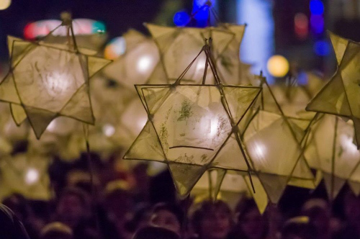
Nailsea Community Christmas Fair 2016
Contact Form
Thank you for being a part of our festive event on Friday, December 2. We welcome everyone’s involvement towards making 2016 a great success. To help us keep track of those who have asked to be part of what we hope will become an annual festive celebration we are asking people to fill in the form below and return by email to: nailseacommunitychristmasfair@gmail.com or drop into the Tesco customer service desk or The Blue Room
ABOUT YOU
Full name (and if you are representing a business/organisation/charity please include its name and your role):
........................................................................................ .............................................................................................
Contact address:
……………………………………………………………………………………………………………………………………………………………………………………..
Telephone (home, work or mobile):
..................................................................................................................................……………………………………………………….
Email:
……………………………………………………………………………………………………………………………………………………………………………………..
How you would like to be involved: planning committee/volunteer/stallholder/pre-publicity activities:

............................................................................................................................................................................................
Are you available for evening meetings and/or to help on the day (delete as appropriate): YES/NO
Further information including our next planning committee (date, time and venue) is on our Facebook page or at www.nailseapeople.com Nailsea Community Christmas Fair page

