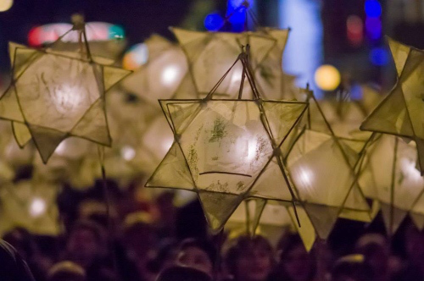
Nailsea Community Christmas Fair 2016
Performers/lantern holders for Friday, December 2
We will need lots of singing and dancing for this festive event so this is an invitation to you to get involved for performances in Nailsea town centre and those intending to join the lantern parade which will start outside Wetherspoons and make its way towards Tesco Nailsea stopping on route for the switching on of the Christmas tree lights at Somerset Square.
Please complete and return this form by Friday, November 3, either by email to nailseacommunitychristmasfair@gmail.com or dropping into the Tesco Nailsea customer service desk or The Blue Room, Crown Glass shopping centre keeping a copy for your own records.
Please fill in your details below:
Contact name:

Name of choir/dance troupe/school/organisation:

Contact telephone number:

Contact email address:

Brief outline of the type of group taking part which will be used to promote fair:

Approximate numbers taking part
Any special requirements?

.
For more information or any queries please contact:
Please tick if you or a representative (state number) would like to attend a lantern making workshop in Nailsea which may be at a weekend

