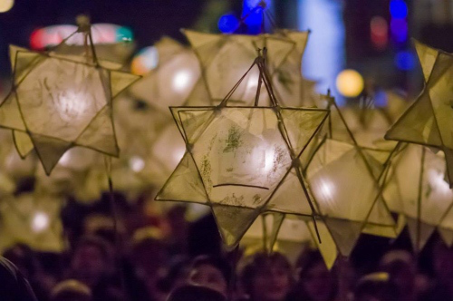
Nailsea Community Christmas Fair 2016
Stall booking form for Friday, December 2
Set up is from midday. Event opens from 5.30-8.30pm. Vehicle access and name of person managing stalls to be advised. Please complete and return this form by Friday, November 3, either by email to nailseacommunitychristmasfair@gmail.com or dropping into the Tesco Nailsea customer service desk or The Blue Room at Crown Glass shopping centre keeping a copy for your own records.
Please fill in your details below:
Contract name:

Company/Business/Charity name:

Contact address (if no email):

Contact telephone number:

Contact email address:

Brief outline of the type of stall and goods to be sold/promoted which will be used to promote fair:

Number of people manning stall on the night and person in charge

Stallholders will need to bring their own tables/covers/gazebos and they will be responsible for setting up, dismantling and clearing their area. There may be a limited number of canopies (as used on market day) available for an extra cost. The standard space is the width of one trestle table and the charge is £10 for local clubs, organisations and charity stalls and £20 for commercial stalls. Please tick box right to indicate if interested in a canopy. Position of stall will be on a first come first served basis so it is important to prepay asap.
Please be aware all participants need to provide proof of public liability insurance and include
a copy with this booking form.
For online banking payment use the NCCF account sort code 30-18-88 account number 01666656 by cheque made out to Nailsea Community Christmas Fair. Ring amount paid here £10 or £20.
For more information or any queries please contact:
Please tick as appropriate:
Online payment made Cheque enclosed

