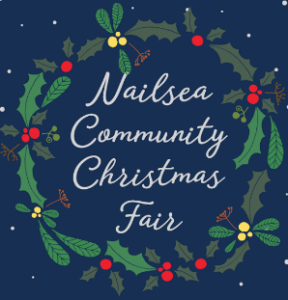
NAILSEA COMMUNITY CHRISTMAS FAIR
Tuesday, May 2
at 7.30pm Garden Room, Trinity Centre, Nailsea
Agenda
- Apologises: John Hunter, Clare Elswood
- minutes of the meeting 27.02.17 draft previously circulated
- matters arising unless an agenda item:
- minutes secretary rota – Sharon Colley agreed to take 02.05.17 minutes
- Lantern parade – report from Sharon – hold until next meeting
- Suggested filler from John Hunter – hold until next meeting

- Crown Glass manager Rob Stokell discussion to include: entertainment to be booked; staging, lighting and sound issues; invited personality for light switching; litter, security and parking
- chairman’s report
- secretary’s report
- treasurer’s report
- any other business
- date of next meeting and venue
Secretary report:
- street trading licence – see email previous circulated
- new stall booking form sent out to 55+ previous stallholders and interested bodies, one email and one reply by post already!
- skate rink – still no respond, another email sent
- update raffle – we need to submit licence request. Prizes so far we have two carvery vouchers for 2016 (finally delivered and used, thank you from winner) and 2017 from Ring O’Bells; 2X4 Bristol Hippodrome Aladdin panto tickets plus sent request to Cadbury House for MPW complimentary Sunday lunch vouchers
- Nailsea Chamber of Trade & Commerce has appointed Rebecca Perfect, of Wards solicitors, as NCCF liaise person

