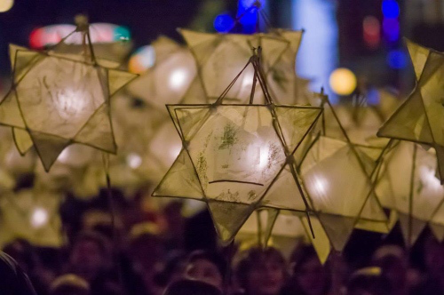
Nailsea Community Christmas Fair 2016
Late night opening/sponsorship/grand raffle donations for Friday, December 2
We are inviting local businesses to support the revival of our festive street fair at Nailsea town centre.
The intention is for a lantern parade to start outside Wetherspoons and make its way towards Tesco Nailsea stopping on route for the switching on of the Christmas tree lights at Somerset Square from 5.30-8.30pm on the Friday night although the skate rink at Crown Glass Place in the shopping centre will also be open all day on Saturday, December 3.
As well as the Christmas lights switch-on there will also be a Santa’s Grotto, clowns and walk-about entertainers, carol singers and dancers, pop-up photoshop, hoopla, swing-boats, inflatable helter-skelter, arts and craft stalls, street food, singers, dancers and musicians and much more.

Sponsorship packages include:
- £50 for logo on skate rink tickets
- £150 towards cost of first aiders
- £150 towards cost of lantern workshop(s)
- £150 towards cost of grand raffle prize
- £300 towards cost of printing posters/flyers
- £500 towards cost of skate rink
Sponsors will get complimentary advertisement in NCCF programme and/or opportunity to display banners on the lantern parade route or on the skate rink barriers.

Please complete and return this form with the necessary artwork/logo either by email to nailseacommunitychristmasfair@gmail.com or dropping into the Tesco Nailsea customer service desk or The Blue Room, Crown Glass shopping centre keeping a copy for your own records. Please fill in your details below:
Contact name and position within company:

Name and address of business:
- Contact telephone number
- Contact email

Our company will be happy to donate a grand raffle prize and/or support with sponsorship. Please give details:

For more information or any queries please contact:

